#### 

A Team

Library Project

Graphical User Interface

Prepared By: Jonathan Seigle

Edited and Approved By: Brian Combs and Juan Maldonado

Table of Contents

Introduction 4

About this document 4

References 4

Graphic treatment 4

Version Information 4

Structure and Navigation 5

User Interface Standards 5

Assumptions 5

Navigation 6

Screen Descriptions 8

Log In / Welcome Screen 8

Description 8

Navigation 9

Issues 9

Elements 9

Patron Group 11

Search 11

Description 11

Navigation 12

Issues 12

Elements 12

Details Screen 12

Description 12

Navigation 13

Issues 13

Elements 13

My Reservations Screen 13

Description 13

Navigation 14

Issues 14

Elements 14

My Account 14

Description 14

Navigation 15

Issues 15

Elements 15

Circulation Group 16

New Account 16

Navigation 17

Issues 17

Elements 17

Check In 17

Navigation 17

Issues 17

Elements 17

Check Out 17

Navigation 18

Issues 18

Elements 18

Accounts 18

Navigation 19

Issues 19

Elements 19

Administration Group 20

Catalogue Manager 20

Navigation 21

Issues 21

Elements 21

Account Manager 21

Navigation 22

Issues 22

Elements 22

Help Group 23

FAQ 23

Navigation 24

Issues 24

Elements 24

Contacts 24

Navigation 24

Issues 24

Elements 24

About 24

Navigation 25

Issues 25

Elements 25

Interface and Program Validation 26

# Introduction

This document describes the User Interface for the A Team Library Project Database.

## About this document

The remainder of this document is divided into the following sections:

* *Structure and Navigation* describes the structure of the application, and the ways in which users can navigate.
* *Screen Descriptions,* which comprises the main part of the document, contains a description of each screen and proposed component parts.

## References

Refer also to the following documents:

*A Team Project Charter*, dated June 8 2017.

*A Team Requirement Documentation,* date June 9, 2017

*A Team High Level Software Design,* dated June 13, 2017

*Project Entity Relationship Diagram*, date June 19, 2017

*Master Project Object Design,* July 6, 2017

## Graphic treatment

No graphic treatment has been conducted. Therefore, the screen representations in this document should be considered as preliminary until which time they are finalized. These elements will be contained within screens; but will appear differently and are only a representation of their final appearance.

## Version Information

Version 1.0 UI and UX Concept June 9, 2017

Version 2.0 UI and UX Concept July 23, 2017

# Structure and Navigation

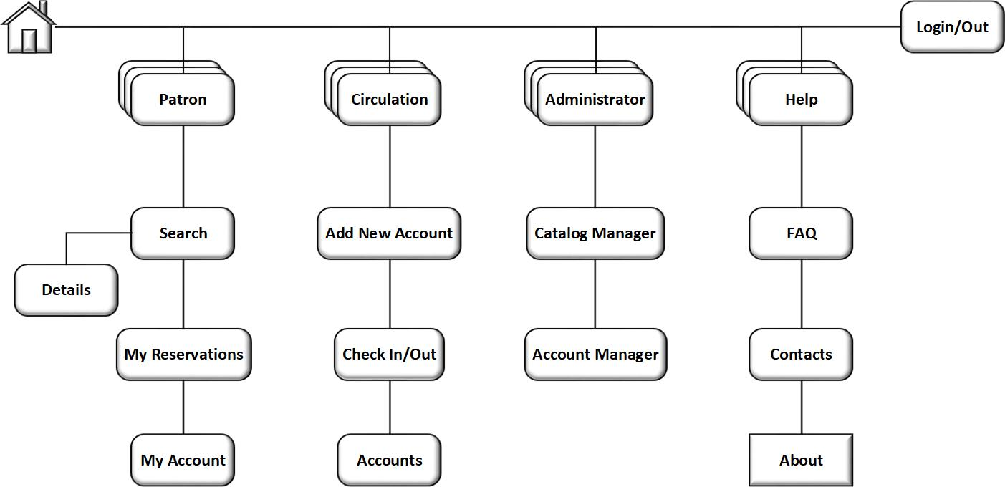The overall structure of the application is relatively simple, as shown in the following diagram.

Note: Names in the diagram provide a cross-reference to individual screens described in this document.

There are four primary groups with multiple screens for each in the program interface, and each of these may be accessed directly from the menu strip along the top of the window (in addition to the ‘Log In / Log Out’). While all are scene in the menus, access is controlled by privilege level established at log in.

## User Interface Standards

Design standards will be used to maintain consistency in the user interface throughout the system. The illustrations provided in this document will be used a base to each screen interaction. The menu strip will remain present for all screens and provide a consistent base for maneuvering through the program. The process display will be determined by the navigation interaction and maintain a common design and object location to provide consistency. The colors and font selected will remain the same throughout. For example the standard Patron settings will remain consistent for all screens and header, as well as the leveled accounts will consistency for the appropriate access as a Librarian or Administrator.

## Assumptions

It is assumed that Library Management will be running on a Windows 7 or newer machine.

# Navigation

Within the screens, primary navigation is to be provided on the top of the screen, in a horizontal menu strip divided by privilege level. This will be described in detail in the Log In Screen section.



Screens are displayed in a single browser window, with the indivdual screen displayed below. Some screens may have divided views depending on content. The window its self does not contain browser controls. The Close and Minimize buttons are provided.

The menu strip is divided by the privlaged areas starting left to right with the least privlage to higher. The far right access to the Help sub-menu does not require any privalged access.

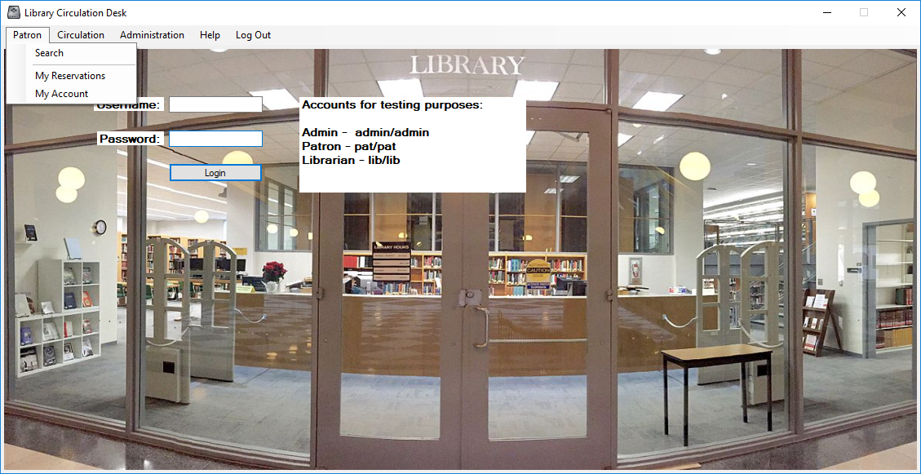**PATRON SUB-MENU**

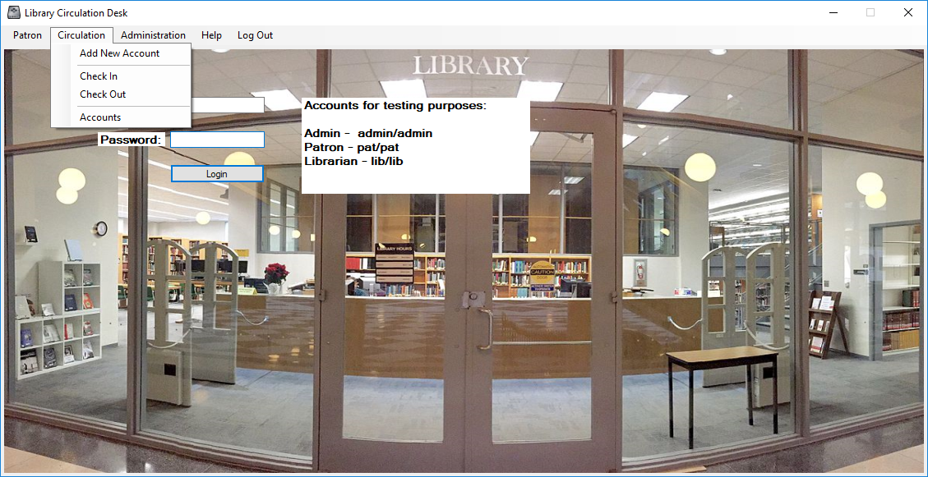**CIRCULATION SUB-MENU**

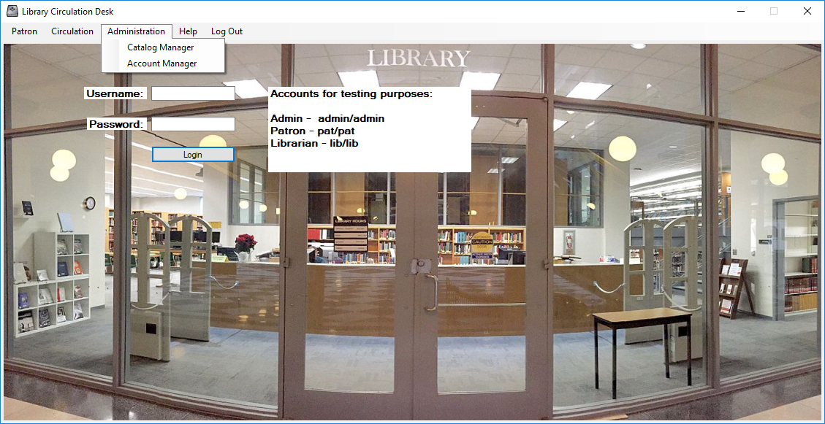**ADMINISTRAION MENU**

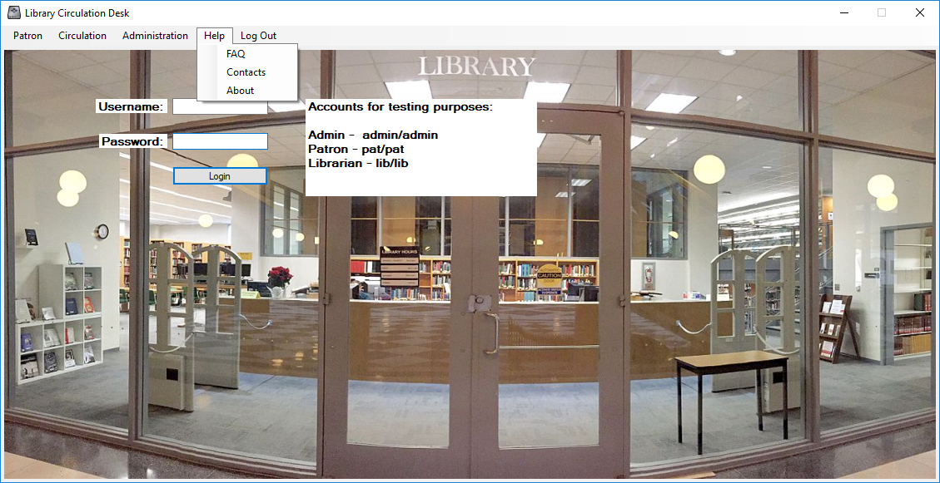**HELP**

# Screen Descriptions

This part of the document contains detailed descriptions of each screen in A Team Project.

Unless otherwise noted, no graphic treatment has yet occurred and is otherwise conceptual.

## Log In / Welcome Screen

### Description

The Menu Strip will be available at all times while using the program. The upon load, the program will open the Log In screen, as this is will determine access levels for the remainder of the program. All navigation can then be accessed through the menu strip, that will be boldened to the appropriate access level.

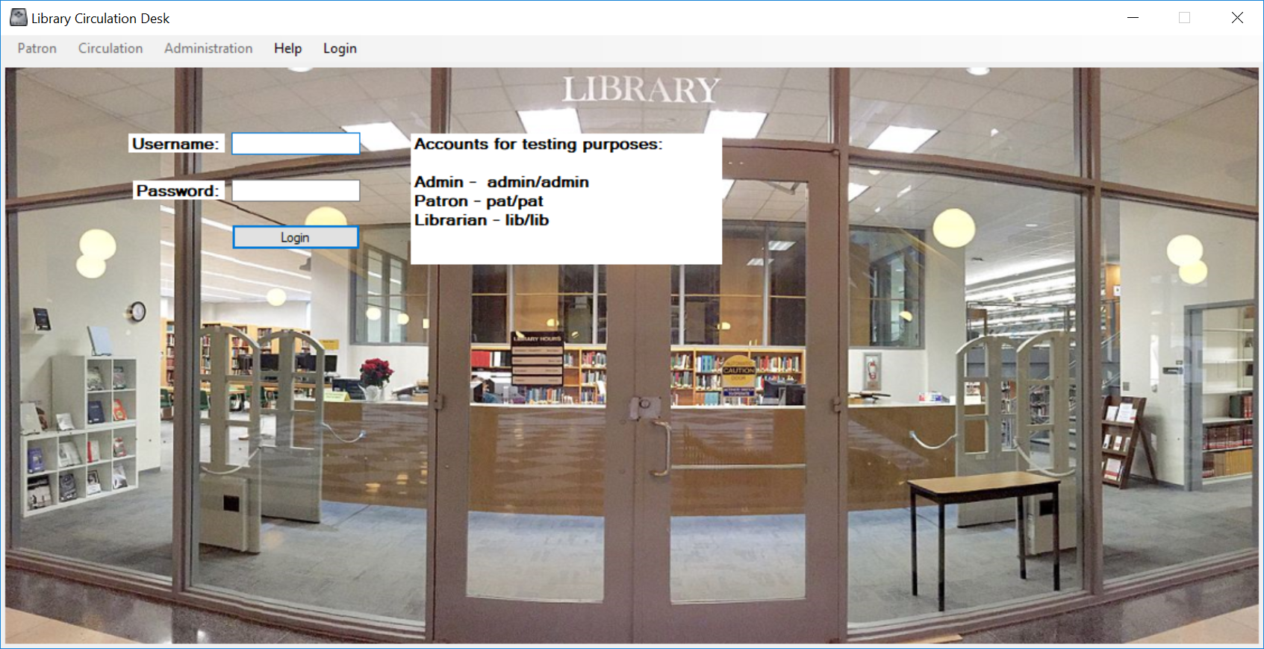**OPEN SCREEN MENU WITH LOG IN**

Patron users will have only the Patron menu navigable, Librarians will have Patron and Circulation navigable, and Administrators will be able to navigate all menus. Help will be navigable for everyone.

Upon submitting proper credentials, the display will make available the menu items. The user may then navigate to the requested window within the menu strip. Each area will have defined secondary navigation buttons. As long as the user remains in the same privilege level; the menu strip will not change.

**PATRON LOG IN SUCCESSFUL**

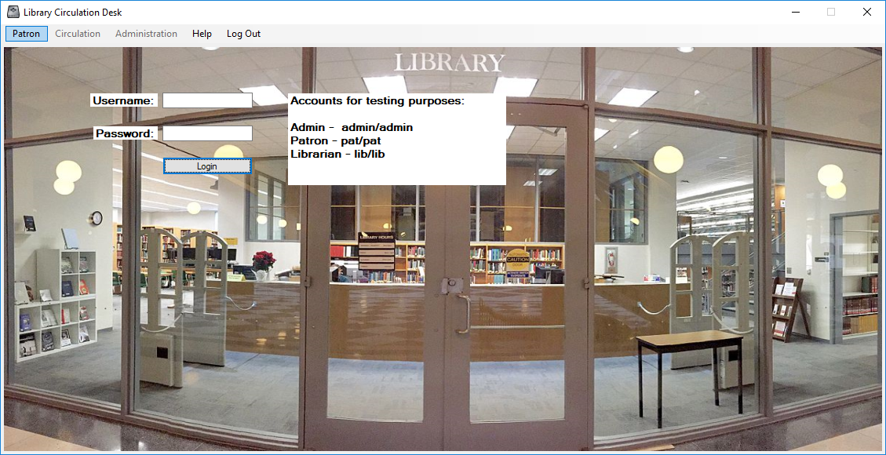

**LIBRARIAN LOG IN SUCCESSFUL**

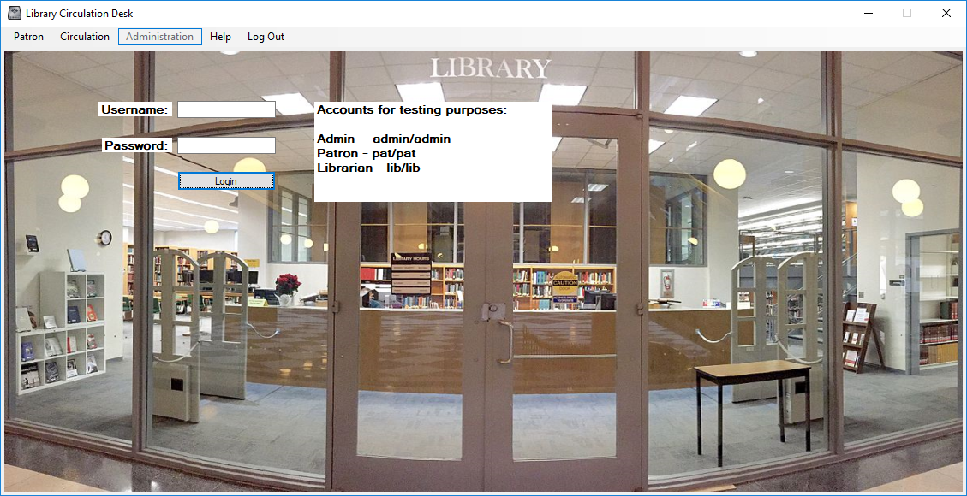

**ADMINISTRATION LOG IN SUCCESSFUL**

#### 

### Navigation

Navigation to the Log In screen is automatic at load and by clicking the Log Out Button on the menu strip. Levelled up access will be necessary to accessing Patron, Librarian or Admin areas and will become available after authentication.

### Issues

Unresolved issues or special conditions or considerations.

1. At final production, no issues were discovered with the menu access or login.

# Patron Group



## Search

### Description

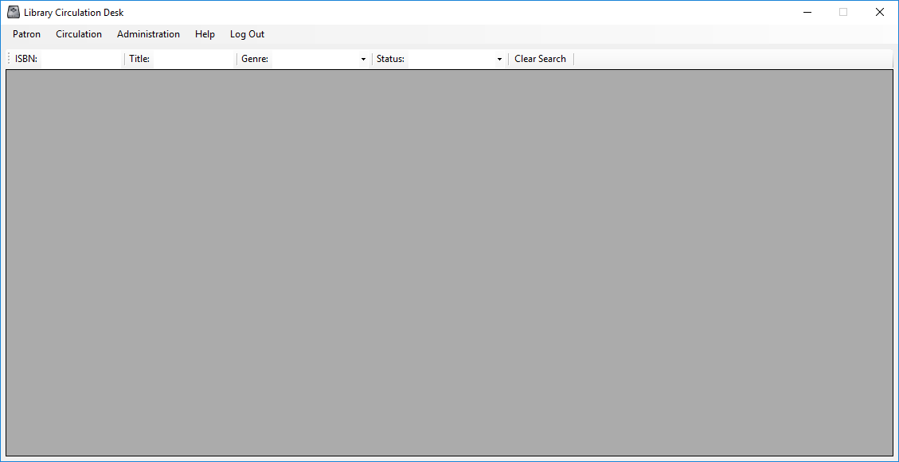 The Search screen is used to view and filter all books available in the library catalogue. Using the Tool Strip you may search using ISBN, Title, Genre and Book Status. The ISBN and Title text boxes are activated at change. This means as you type your filter word out, it will search at each letter or number you type. The Genre and Status drop downs will search upon selection (click). Each drop down displays all possible results as they exist in the catalogue, so false returns will not occur.

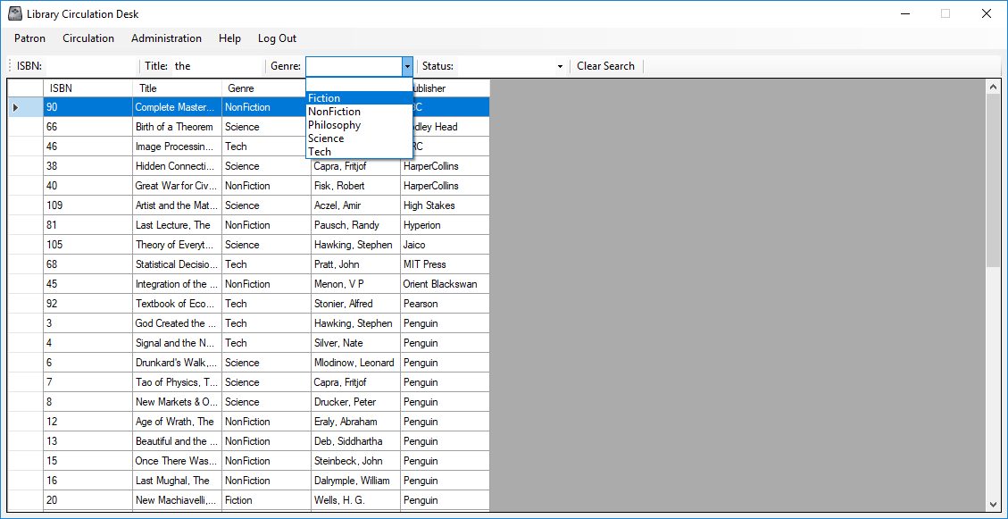 Once the user has located the desired book they can select (click) on the item and the program will move to the details screen. If the user wishes to start over, selecting the Clear Search will return the full catalogue.

### Navigation

Navigation to the Search screen provided through the Patron Sub Menu in the Menu Strip. Levelled up access is required for access to at least a Patron user. All elevated levels also have access after authentication.

### Issues

Unresolved issues or special conditions or considerations.

1. At final production, no issues were discovered with the menu access or login.

## Details Screen

### Description

The Details screen is used to view all information of a chosen book from the library catalogue. The screen shows the Title, Genre, Author, and Publisher. The information area is read only to all levels of privilege.

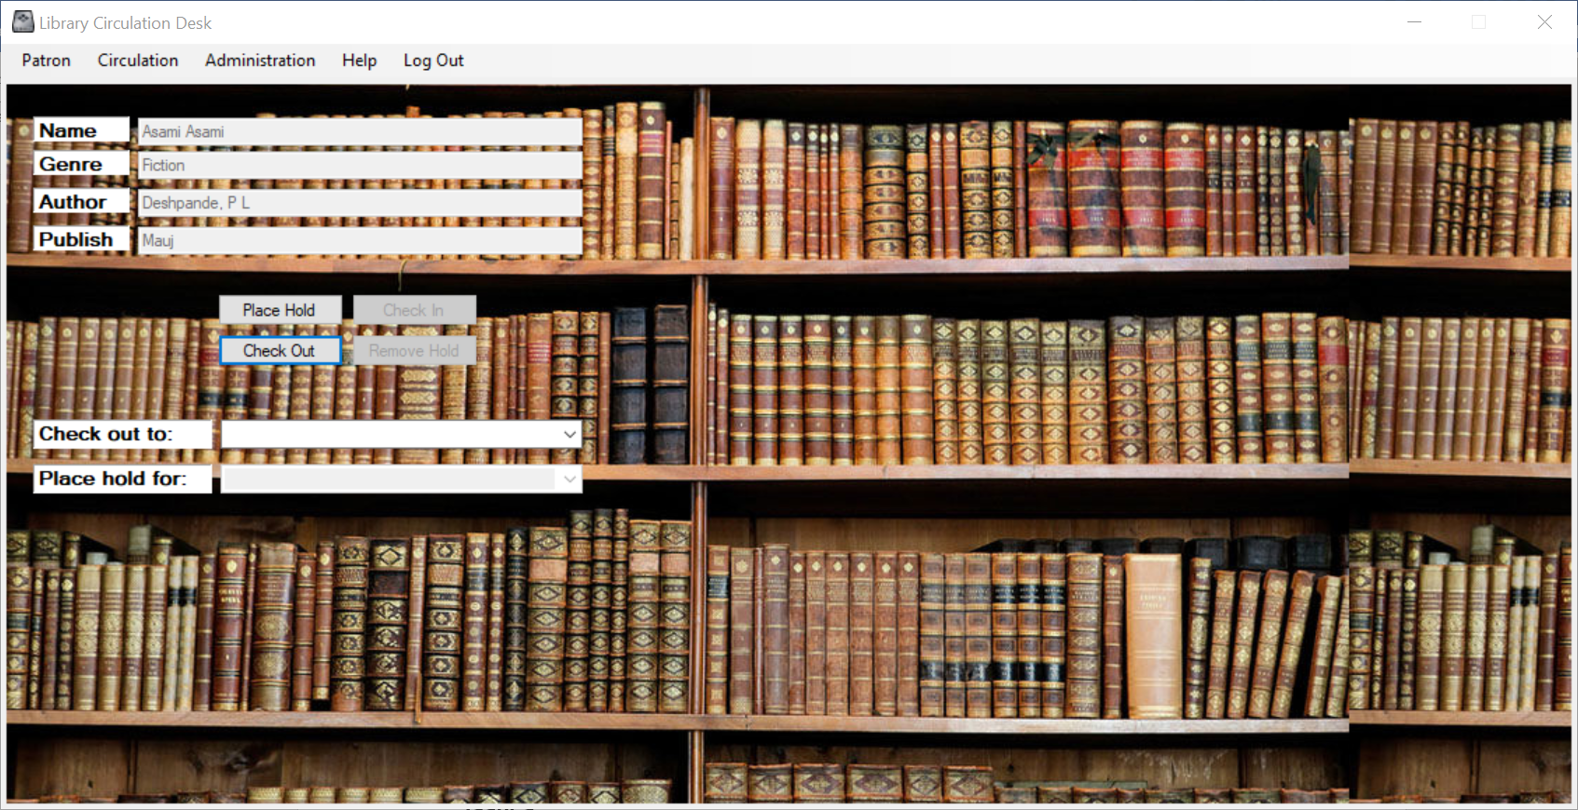 A Patron has access to Place Hold and Remove Hold buttons only. As these will affect the users account only. A pop up will indicate.

A Librarian and Administrator have the same abilities as a Patron and the following abilities. Check Out and Check In for their own account using the provided buttons. They may also check out to an account with the drop-down menu. Selecting the account will activate the check out and a pop up will indicate. This is also provided for placing holds for other accounts using the same process and the provided drop-down.

Once the user has completed the desired transaction, they may continue through the use of the Menu Strip. Search parameters are saved for ease of use.

### Navigation

Navigation to the Details screen is only possible through the Search screen. This is required in order to locate and select the desired item.

### Issues

Unresolved issues or special conditions or considerations.

1. At final production, a desire to add a verification to the For processes was addressed and will be included in future versioning.

## My Reservations Screen

### Description

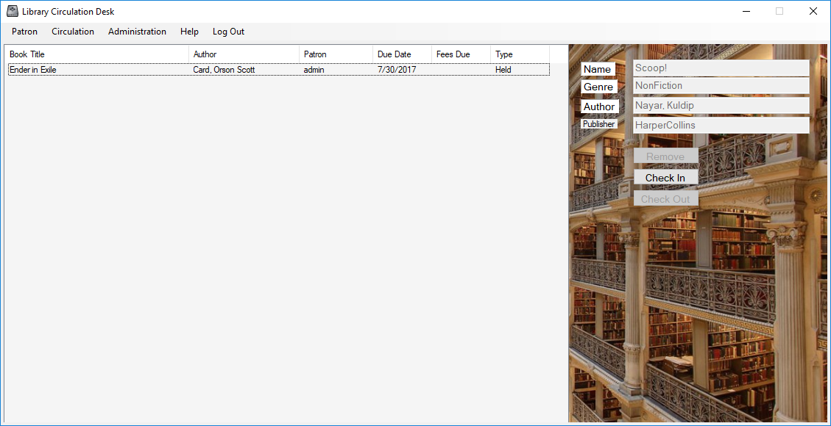 The My Reservations screen is used to view the users reservation list. The left side of the screen provides a list of all reservations the account has in place. The type column identifies if the reservation is Held or Current, and if the reservation has expired. After selecting the item in the main list, the detail information is presented and the action will be performed on the item.

Patron level may only remove their reservation using the provided button.

Librarian and Administrators can Check Out items to themselves only on this screen.

### Navigation

Navigation to the My Reservations screen provided through the Patron Sub Menu in the Menu Strip. Levelled up access is required for access to at least a Patron user. All elevated abilities are also restricted the accounts access level.

### Issues

Unresolved issues or special conditions or considerations.

1. At final production, no issues were discovered with the menu access or login.

## My Account

### Description

The My Accounts screen provides the user an ability to view their own account information. This screen only provides the logged in user access to their information. The right portion of the screen provides account ID, Date Created and Balance in a read only status. Username is editable. And Type can be edited, dependent upon the account level of Administrator. Note: if and Administrator drops their own privileges, they cannot replace them later. Another administrator must provide that service.

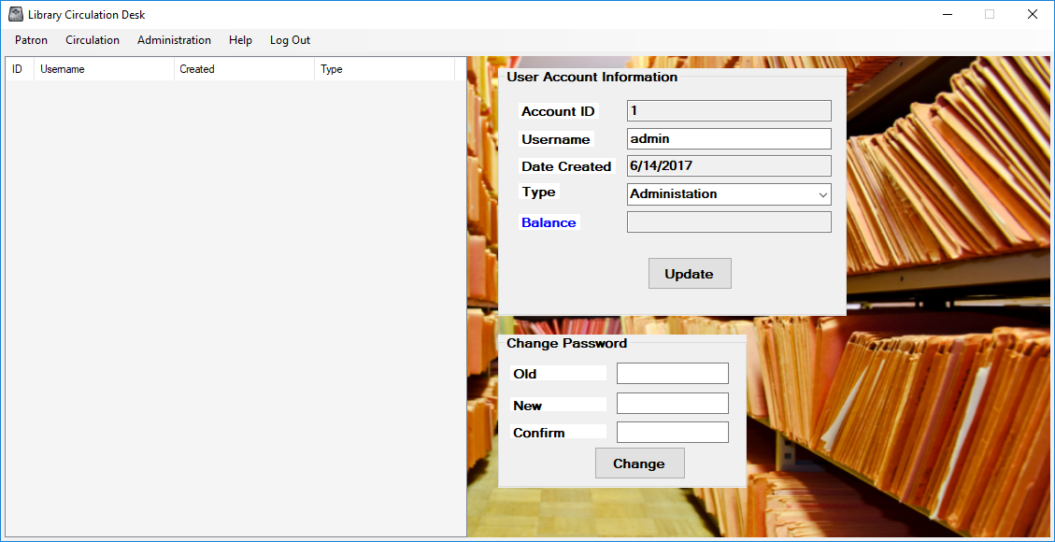

Below account information is the Change Password group. Here the user must provide the current password and then enter and confirm their new desired password. A message will indicate if the process was successful or if information was not provided correctly.

### Navigation

Navigation to the My Account screen provided through the Patron Sub Menu in the Menu Strip. Levelled up access is required for access to at least a Patron user. All elevated abilities are also restricted the accounts access level.

### Issues

Unresolved issues or special conditions or considerations.

1. At final production, the Librarian access level was considered for ability to promote Patron to Librarian, this was deemed unnecessary due too administrative concerns.

# Circulation Group

This section is no accessible by the Patron Level Accounts. Only Librarian and Administrators my access these services.



## New Account

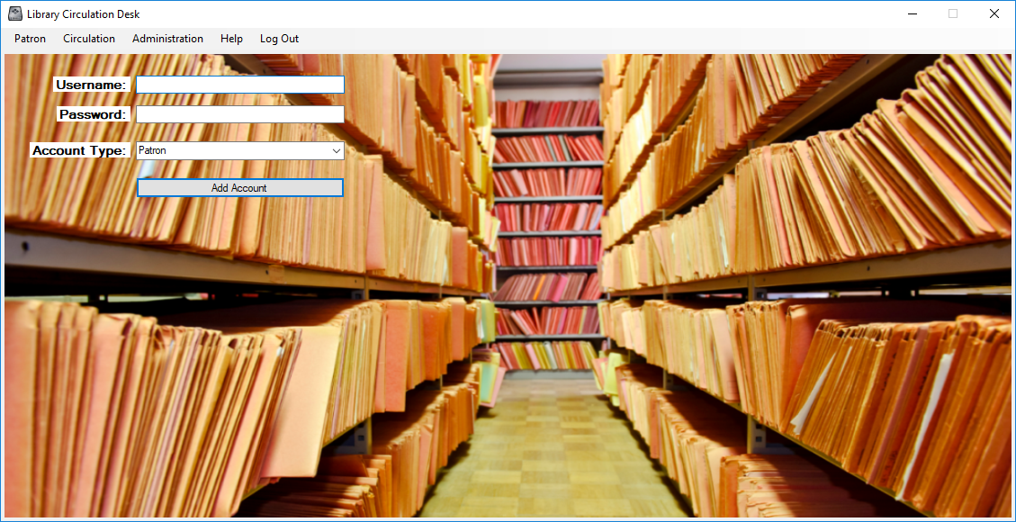 The New Account screen provides the management entities the ability to create new accounts to the catalogue program. The username is determined by the administration during in-processing and is given an initial password. (It is the user’s responsibility to update the password after first log in) Librarians can only create Patron accounts and Administrators are able to create all 3 levels of accounts.

### Navigation

Navigation to the New Accounts screen provided through the Circulation Sub Menu in the Menu Strip. Levelled up access is required for access to at least a Librarian user. All elevated abilities are also restricted to the accounts access level.

### Issues

Unresolved issues or special conditions or considerations.

1. At final production, the Librarian access level was considered for ability to promote Patron to Librarian, this was deemed unnecessary due too administrative concerns.

## Check In

Check In is an advanced version of the My Reservations screen. Here the user may view all checked out items from the catalogue. The left screen provides all items by Title, Author, Username, Due Date, Fees and Status. The status will state either Check Out or Overdue.

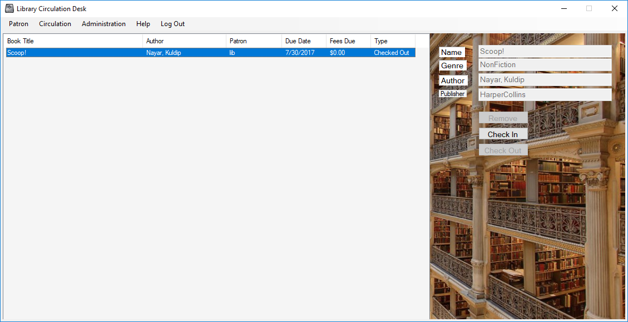

When an item is selected the information is filled in on the right details screen. Here the user may Check In the item using the provided button. A message box will state if the process was successful. The remaining buttons are not required for this screen and are disabled.

### Navigation

Navigation to the Check In screen provided through the Circulation Sub Menu in the Menu Strip. Levelled up access is required for access to at least a Librarian user. All elevated abilities are also restricted to the accounts access level.

### Issues

Unresolved issues or special conditions or considerations.

1. At final production, no issues were identified.

## Check Out

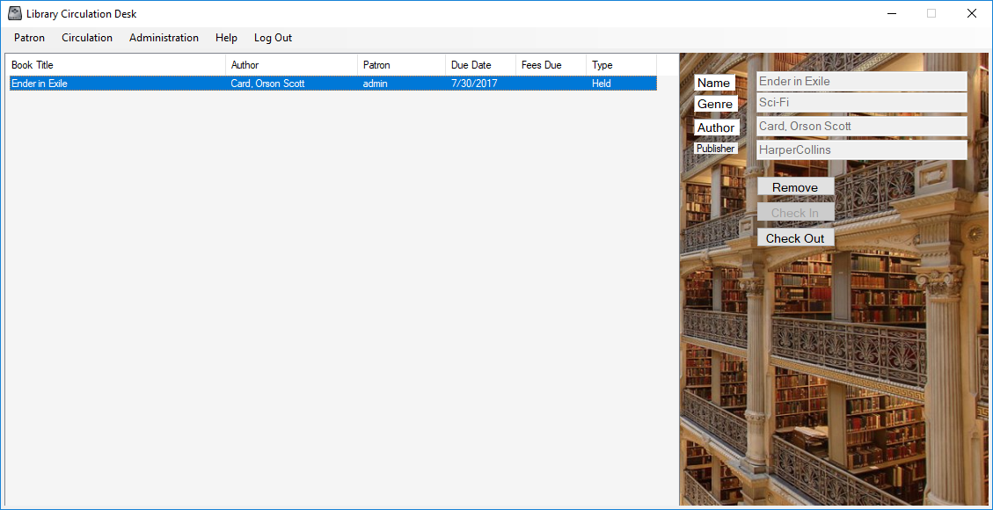 Check Out is an advanced version of the My Reservations screen. Here the user may view all reserved items from the accounts. The left screen provides all items by Title, Author, Username, Due Date (When the Hold Expires), Fees(Blank in this screen) and Status. The status will state either Held or Hold Expired.

When an item is selected the information is filled in on the right details screen. Here the user may Check Out the item using the provided button or Remove the Hold on the item. A message box will state if the process was successful. The remaining button is not required for this screen and is disabled.

### Navigation

Navigation to the Check Out screen provided through the Circulation Sub Menu in the Menu Strip. Levelled up access is required for access to at least a Librarian user. All elevated abilities are also restricted to the accounts access level.

### Issues

Unresolved issues or special conditions or considerations.

1. At final production, no issues were identified.

## Accounts

The Accounts screen is an advanced version of the My Accounts screen. Here management can view all accounts in the left table. Here is states the ID number, Username, Date Created and Type.

The user may select and account and the details will be presented in the right pane. Here all the information is again displayed. Account ID, Date Created and Balance are read only. Username and Type are editable. Note only an Administrator may elevate an account Type in the Account Manager service.

Below account information is the Change Password group. Here the user must provide the current password and then enter and confirm their new desired password. A message will indicate if the process was successful or if information was not provided correctly.

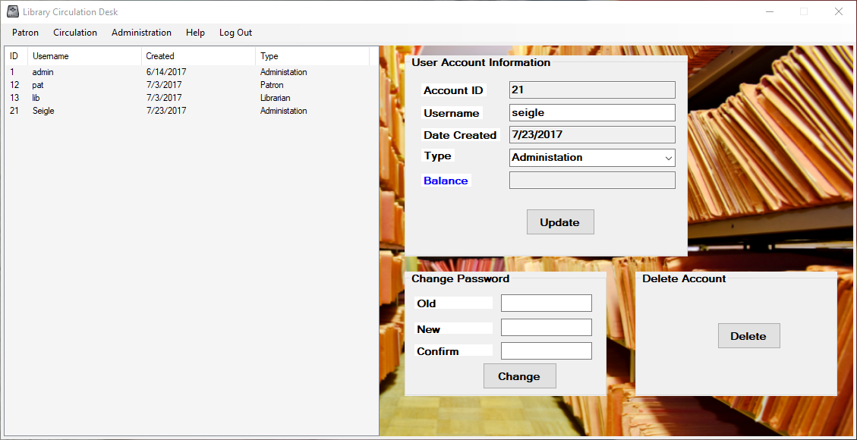 An additional box for account deletion is also available here. Note that you cannot delete an account that has a check out item or and existing hold. The account must be clear before it can be deleted.

### Navigation

Navigation to Accounts screen provided through the Circulation Sub Menu in the Menu Strip. Levelled up access is required for access to at least a Librarian user. All elevated abilities are also restricted to the accounts access level.

### Issues

Unresolved issues or special conditions or considerations.

1. At final production, an issue was identified to allow administrators reset passwords without requiring the Old Password, to assist with account lockouts. This will be available in future versions.

# Administration Group

The Administration Group is not accessible by the Patron or Librarian level accounts. Only the administrative level accounts my use these services.



## Catalogue Manager

The Catalogue Manager screen is for control of library inventory. Here the administrator may view the entire catalogue using the left table.

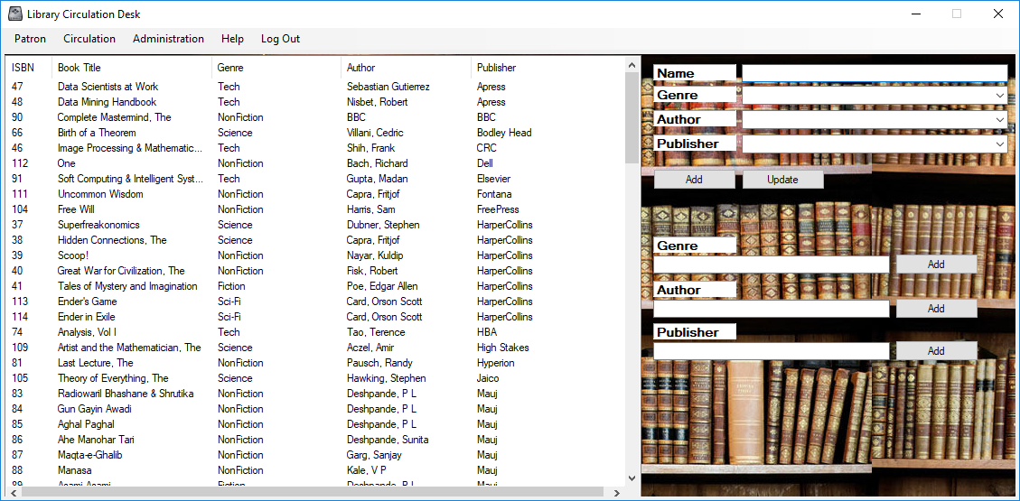

Selecting an item pulls detail information into the right pain for editing purposes. The admin may also entire new item information and add to the catalogue through this interface.

Below are additional items that can be added to the catalogue that may not be associated with any one item. Here they may add Genre, Author or Publisher if more than one is available to any one book.

### Navigation

Navigation to the Catalogue Manager screen provided through the Administration Sub Menu in the Menu Strip. Levelled up access is required for access to at least an Administrator.

### Issues

Unresolved issues or special conditions or considerations.

1. At final production, no issues were identified.

## Account Manager

The Account Manager screen is the highest privilege for account control. The Accounts screen is an advanced version of the My Accounts screen. Here management can view all accounts in the left table. Here is states the ID number, Username, Date Created and Type.

The user may select and account and the details will be presented in the right pane. Here all the information is again displayed. Account ID, Date Created and Balance are read only. Username and Type are editable. Here is the only service to provide the Administrator an ability to elevate an account Type above Patron.



Below account information is the Change Password group. Here the user must provide the current password and then enter and confirm their new desired password. A message will indicate if the process was successful or if information was not provided correctly.

An additional box for account deletion is also available here. Note that you cannot delete an account that has a check out item or and existing hold. The account must be clear before it can be deleted.

### Navigation

Navigation to the Account Manager screen provided through the Administration Sub Menu in the Menu Strip. Levelled up access is required for access to at least an Administrator.

### Issues

Unresolved issues or special conditions or considerations.

1. At final production, no issues were identified.

# Help Group

The Help Group is for informational purposes. This is accessible by all users who have access to the program and does not require any authentication.



## FAQ

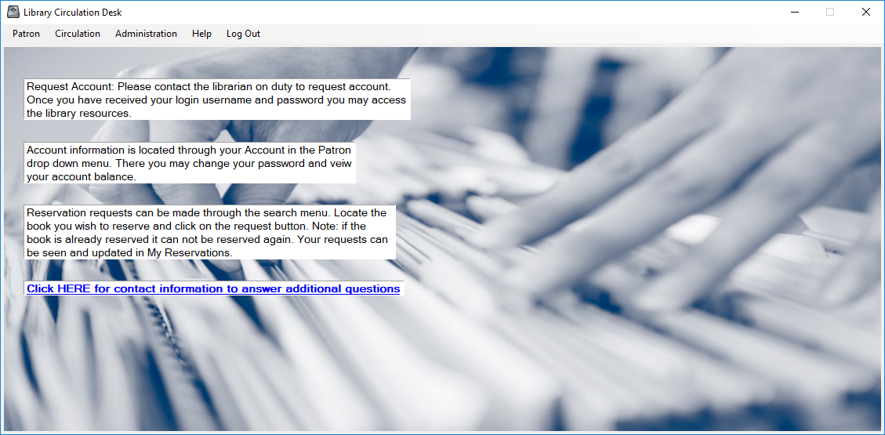 The FAQ screen provides frequently asked questions about the program. Currently the screen maintains basic help tips to using the program but will be edited as users provide feedback to better navigate the catalogue as needed.

The page also includes a link to the contacts page described in the next section.

### Navigation

Navigation to the FAQ screen provided through the Help Sub Menu in the Menu Strip. No levelled-up access is required for access. All users with access to the program may use this screen.

### Issues

Unresolved issues or special conditions or considerations.

1. At final production, the page is recognized as a living document and will be updated as needed.

## Contacts

The Contacts Screen provides information to contact the library administration.

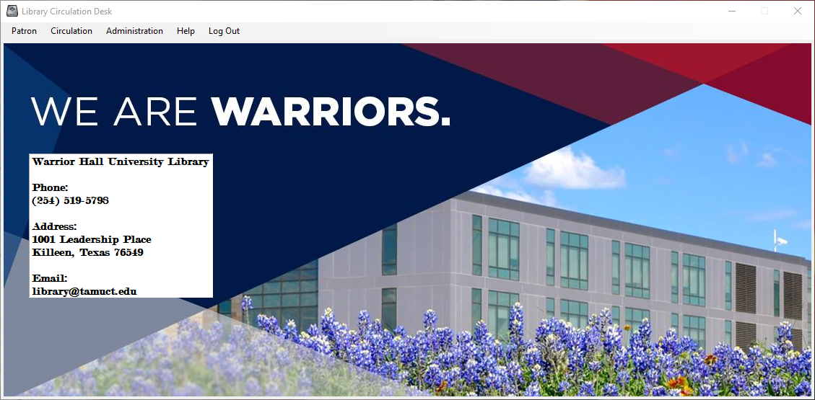

### Navigation

Navigation to the Contacts screen provided through the Help Sub Menu in the Menu Strip. No levelled-up access is required for access. All users with access to the program may use this screen.

### Issues

Unresolved issues or special conditions or considerations.

1. At final production, no issues were identified.

## About

The About Screen provides information about to the program. Title, Author, Copyright and Service Dates are provided through a pop-up window. Pressing OK closes the pop-up.

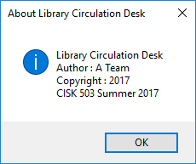

### Navigation

Navigation to the Contacts screen provided through the Help Sub Menu in the Menu Strip. No levelled-up access is required for access. All users with access to the program may use this screen.

### Issues

Unresolved issues or special conditions or considerations.

1. At final production, no issues were identified.

# Interface and Program Validation

The following testing protocol is used to verify proper development of the catalogue program. These steps should be completed after initial installation to ensure all parts were correctly installed. Additionally, validation steps should be taken if database changes, under goes maintenance or is manually edited. Sign off of validation is required by developer team as well as receiving party prior to closure.

1. Load to Log In Screen
   1. Patron Menu Locked
   2. Circulation Menu Locked
   3. Administration Menu Locked
   4. Help Menu Access
      1. FAQ
         1. Information displayed
         2. Contacts link works correctly
      2. Contacts
         1. Correct information displayed
      3. About
         1. Information Pop Up Opens
         2. Close with OK Button
2. Log In Menu Item returns to Log In
3. Patron Default Account Authorized (pat / pat)
   1. Patron Menu Released to Privilege Level
      1. Search
         1. At change filter works correctly for ISBN and Title
         2. Genre and Status Drop Down filter correctly
         3. Clear Search returns to full listings
         4. Clicking on information row of book moves to reservation request screen.
      2. Reservation Screen
         1. Proper book displayed
         2. Place Hold Button Available
         3. Place Hold Button places hold, confirmation for successful hold or error for duplicate hold
         4. **Remove Hold Button available**
         5. Check In, Check Out Buttons not available
         6. Check Out To: Drop Menu not available
         7. Place Hold For: Drop Menu not available
      3. Return to Search shows book reserved
      4. My Reservations
         1. Reserved book shows in My Reservations
         2. Remove Hold Button available
         3. Remove Button executes, returns proper removed message.
            1. Updates reservation list
         4. Check In, Check Out Buttons unavailable
      5. My Account
         1. Correct account ID displayed and disabled
         2. Correct username and enabled
         3. Correct date created and disabled
         4. Correct Type selected in drop down menu and enabled
         5. Correct balance displayed disabled
         6. Update allows user name change
         7. Update does not allow type change, returns to Patron
         8. Change Password **(Do Not Use Default Accounts to Test)**
            1. Verifies passwords match, attempt mismatch
            2. Verifies correct password, attempt incorrect
            3. Changes password
   2. Circulation Menu Locked
   3. Administration Menu Locked
   4. Help Menu Access
      1. FAQ
         1. Information displayed
         2. Contacts link works correctly
      2. Contacts
         1. Correct information displayed
      3. About
         1. Information Pop Up Opens
         2. Close with OK Button
4. Log Off Menu Item releases account and returns to Log In screen
   1. Patron Menu Locked
   2. Circulation Menu Locked
   3. Administration Menu Locked
   4. Help Menu Access
      * 1. FAQ
        2. Contacts
        3. About
5. Librarian Default Account Authorized (lib / lib)
   1. Patron Menu Released to Privilege Level
      1. Search
         1. At change filter works correctly for ISBN and Title
         2. Genre and Status Drop Down filter correctly
         3. Clear Search returns to full listings
         4. Clicking on information row of book moves to reservation request screen.
      2. Reservation Screen
         1. Proper book displayed
         2. Place Hold Button Available
         3. Place Hold Button places hold, confirmation for successful hold or error for duplicate hold
         4. Check Out Button available and activates correctly
         5. Check In available
         6. Remove Hold Button not available
         7. Check Out To: Drop Menu available and activates correctly
         8. Place Hold For: Drop Menu available
      3. Return to Search shows book reserved
      4. My Reservations
         1. My Reservations shows Reserved books
         2. Remove Hold Button available
         3. Remove Button executes, returns proper removed message.
            1. Updates reservation list
         4. Check In, Check Out Buttons available, responds correctly
      5. My Account
         1. Correct account ID displayed and disabled
         2. Correct username and enabled
         3. Correct date created and disabled
         4. Correct Type selected in drop down menu and enabled
         5. Correct balance displayed disabled
         6. Update allows user name change
         7. Update does not allow type change, returns to Patron
         8. Change Password **(Do Not Use Default Accounts to Test)**
            1. Verifies passwords match, attempt mismatch
            2. Verifies correct password, attempt incorrect
            3. Changes password
   2. Circulation Menu Released to Privilege Level
      1. Add New Account
         1. User Account created in Patron level only
      2. Check In
         1. Book Information is read only
         2. Displays checked out books
         3. Check In Button available
         4. Check Out / Remove no available for book
         5. Check In returns responds with appropriate message book and updates display
      3. Check Out
         1. Displays Held books
         2. Book Information is read only
         3. Check In unavailable for book
         4. Check Out / Remove are available for book
         5. Check Out responds with appropriate message book and updates display
         6. Remove responds with appropriate message book and updates display
   3. Administration Menu Locked
   4. Help Menu Access
      1. FAQ
         1. Information displayed
         2. Contacts link works correctly
      2. Contacts
         1. Correct information displayed
      3. About
         1. Information Pop Up Opens
         2. Close with OK Button
6. Log Off Menu Item releases account and returns to Log In screen
   1. Patron Menu Locked
   2. Circulation Menu Locked
   3. Administration Menu Locked
   4. Help Menu Access
      * 1. FAQ
        2. Contacts
        3. About
7. Admin Default Account Authorized (admin / admin)
   1. Patron Menu Released to Privilege Level
      1. Search
         1. At change filter works correctly for ISBN and Title
         2. Genre and Status Drop Down filter correctly
         3. Clear Search returns to full listings
         4. Clicking on information row of book moves to reservation request screen.
      2. Reservation Screen
         1. Proper book displayed
         2. Place Hold Button Available
         3. Place Hold Button places hold, confirmation for successful hold or error for duplicate hold
         4. Check Out Button available and activates correctly
         5. Check In available
         6. Remove Hold Button not available
         7. Check Out To: Drop Menu available and activates correctly
         8. Place Hold For: Drop Menu available
      3. Return to Search shows book reserved
      4. My Reservations
         1. My Reservations shows Reserved books
         2. Remove Hold Button available
         3. Remove Button executes, returns proper removed message.
            1. Updates reservation list
         4. Check In, Check Out Buttons available, responds correctly
      5. My Account
         1. Correct account ID displayed and disabled
         2. Correct username and enabled
         3. Correct date created and disabled
         4. Correct Type selected in drop down menu and enabled
         5. Correct balance displayed disabled
         6. Update allows user name change
         7. Update does not allow type change, returns to Patron
         8. Change Password **(Do Not Use Default Accounts to Test)**
            1. Verifies passwords match, attempt mismatch
            2. Verifies correct password, attempt incorrect
            3. Changes password
   2. Circulation Menu Released to Privilege Level
      1. Add New Account
         1. User Account created in Patron level only
      2. Check In
         1. Book Information is read only
         2. Displays checked out books
         3. Check In Button available
         4. Check Out / Remove no available for book
         5. Check In returns responds with appropriate message book and updates display
      3. Check Out
         1. Displays Held books
         2. Book Information is read only
         3. Check In unavailable for book
         4. Check Out / Remove are available for book
         5. Check Out responds with appropriate message book and updates display
         6. Remove responds with appropriate message book and updates display
   3. Administration Menu Released to Privileged Level
      1. Catalog Manager
         1. Displays Catalog
         2. Displays Detail information
         3. Allows selection of item
         4. Allows edit of selected item
         5. Allows New item creation
         6. Allows Genre addition
         7. Allows Author Addition
         8. Allows Publication Addition
      2. Account Manager
         1. Correct account ID displayed and disabled
         2. Correct username and enabled
         3. Correct date created and disabled
         4. Correct Type selected in drop down menu and enabled
         5. Correct balance displayed disabled
         6. Update allows user name change
         7. Update allows type change to all levels
         8. Change Password **(Do Not Use Default Accounts to Test)**
            1. Verifies passwords match, attempt mismatch
            2. Verifies correct password, attempt incorrect
            3. Changes password
         9. Allows Delete and responds
   4. Help Menu Access
      1. FAQ
         1. Information displayed
         2. Contacts link works correctly
      2. Contacts
         1. Correct information displayed
      3. About
         1. Information Pop Up Opens
         2. Close with OK Button
8. Log Off Menu Item releases account and returns to Log In screen
   1. Patron Menu Locked
   2. Circulation Menu Locked
   3. Administration Menu Locked
   4. Help Menu Access
      * 1. FAQ
        2. Contacts
        3. About

Signature__________________________

Receiving Party

Signature__________________________

Administrative Representative

Signature__________________________

Software Representative

Signature__________________________

User Interface Representative